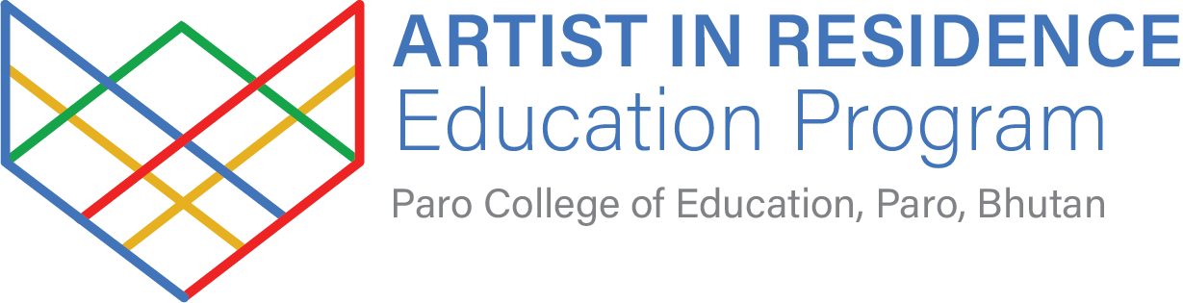
APPLICATION FORM

Artists Full Name
Pronouns
Email Address
Phone Number
Mailing Address
Website/Portfolio
Social Media i.e. Instagram/Facebook
Duration
Indicate how long you would like your residency to be i.e. one, three, or six months.
Sponsorship
Indicate any sponsorship you may have from external organisations. i.e. an organisation may pay your airfare or supply materials
Discipline Area
I.e. sculpture, painting, textiles, film, performance, graphic design etc.
Brief Artist Bio
Max 250 words.
Artist Statement
Max 500 words.
Residency Proposal
Briefly indicate what you intend to focus on during your residency and how this translates into teaching activities. Max 500-words.
Expected Outcomes
i.e. exhibition, community engagement, publication
Residency Alignment
Briefly outline how this project aligns with the goals of the residency Max 500-words.
Discipline Link
What discipline does your residency and subsequent teaching activities link with at Paro College i.e. textiles, literature, visual arts, science, math etc. If you are linking across disciplines, explain how your activity does this.
Resources or Support
What will you need, i.e. studio space, materials, mentorship etc
Preferred Residency Dates
Are you open to alternative dates?
Y/N
Special Accommodations Needed?
If yes please state.
Have you participated in a residency before?
If yes, where and when?
Where did you hear about this residency?
Two References
Include their name, relationship to you, email and phone numbers.
Is there any other relevant information you would like to share?

Declaration: I confirm that the information provided in this application is accurate and that, if selected, I agree to participate in the residency program under the outlined terms.

Signature: __________________________________________________________Date: ________________

